B.Sc(hons),Part I, Atomic Structure- Quantum numbers, Lecture no .1
Dr. A. KHAN, Date- 16/04/2020

Quantum Number
An atom consists of a large number of orbitals which are distinguished from each other on the basis of their shape, size and orientation in space. The orbitals characteristics are used to define the state of an electron completely and are expressed in terms of four numbers as stated, Principal quantum number, Azimuthal quantum number and Magnetic quantum number and Spin Quantum number.
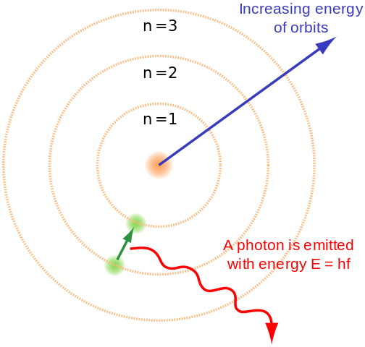
Quantum number are those numbers or alphabets that characterize the electron as under:
- Position of electron from the nucleus i.e radius of different orbits from the nucleus in which electrons are revolving as shown in the fig.
- The energy of each orbit that, also referred as energy level ( n);
n = 1,2,3,……..infinity.
- The shape of the orbital in which electrons are revolving round the nucleus or designation of orbital. An atom consists of a large number of orbitals which are distinguished from each other on the basis of their shape, size and orientation in space. The orbitals characteristics are used to define the state of an electron completely.
- The spinning of electron on its own axis whether clockwise or anticlockwise.
- The total number of orbitals and electrons that can accommodate in an orbit
Number of orbitals in an orbit = n²
Number of electrons in an orbit = 2 n²
For example- n = 1 =K = First orbit , Hence , No. of orbitals = n² = 1
Thus, No. of electron = 2 n² = 2
Each electron has four quantum numbers as following:
- Principle quantum number(n)
- Azimuthal quantum number(l)
- Magnetic quantum number(m)
- Spin quantum number(s)
PRINCIPLE QUANTUM NUMBER-
- The pocket of energy around the nucleus in space where maximum probability of finding electron exists referred as energy level or principal quantum number.
- This number gives the average distance of the electron from the nucleus and correspond to the principal energy level to which electron belongs.
- Principal quantum number designated either as n = 1,2,3,4,5…. Or as K,L,M,N,O….
- The number of orbitals and electrons in n principal quantum number is given as

Number of orbitals = n²
Number of electrons = 2 n²
- The value of energy of nth level is computed as under;

E_{n} = - 2π²m Z² e⁴ / n² h²
Where, m = mass of electron
Z = atomic number , e = charge of electron , h = Plank’s constant
n= 1 or 2 or 3….
AZIMUTHAL QUANTUM NUMBER ( l ):
- It was proposed by Sommerfeld. This donates the sub-level or orbital to which the electro belongs and also determines the shape of the orbital and the energy associated with the angular momentum of the electron.
- For a given value of n , the azimuthal quantum number I may have all integral values fro 0 to n-1 ,
l = 0,1,2 …. ( n – 1 ).
- The different sub-energy level, sub-shell or sub-orbit are usually denoted by letters s , p , d , f …. L =0=s , n= 1= p , l = 2= d, l = 3= f
For Ex-
n | All possible values of l = 0 to n-1 | Name of sub-shell | No of electrons
1 | 0 | 1s | 2
2 | 0 ,1 | 2s ,2p | 8
3 | 0 , 1 , 2 | 3s , 3p , 3d | 18
4 | 0 , 1 , 2 , 3 | 4s , 4p , 4d , 4f | 32

Magnetic Quantum Number( m)
- It is proposed by Lande to explain Zeeman and Strak effects.
- The total number of orbitals in a subshell and the orientation of these orbitals are determined by the magnetic quantum number. It is denoted by the symbol ‘m_{l}’. This number determines the preferred orientations of orbitals in space.
- The value of the quantum is dependent on the value of the azimuthal (or orbital angular momentum) quantum number. For a given value of l, the value of m_{l} ranges between the interval of -l to +l. Therefore, it indirectly depends on the value of n.
For example, if n = 4 and l = 3 in an atom, the possible values of the magnetic quantum number are m = -3, -2, -1, 0, +1, +2, and +3. Or total m = 2l + 1 = 7
Azimuthal Quantum Number Value | Corresponding Number of Orbitals (2l + 1) & name of orbital | Possible Values of m_{l}
0 (‘s’ subshell) | 2*0 + 1 = 1 , 4S | 0
1 (‘p’ subshell) | 2*1 + 1 = 3 , 4p | -1, 0, and 1
2 (‘d’ subshell) | 2*2 + 1 = 5 , 4d | -2, -1, 0, 1, and 2
3 (‘f’ subshell) | 2*3 + 1 = 7 , 4f | -3, -2, -1, 0, 1, 2, and 3
The total number of orbitals in a given subshell is a function of the ‘l’ value of that orbital. It is given by the formula (2l + 1). For example, the ‘3d’ subshell (n=3, l=2) contains 5 orbitals (2*2 + 1). Each orbital can accommodate 2 electrons. Therefore, the 3d subshell can hold a total of 10 electrons.
Note:
To designate a particular subshell we write the number of the shell itself followed by the subshell designator.
n l This illustrates the relationship between "n" and "l".
1 s the first shell has one orbital type associated with it.
2 s p the second shell has two orbital types associated with it.
3 s p d etc
4 s p d f
5 s p d f g
The principle quantum number describes size and energy, but the second quantum number describes shape. The subshells in any given orbital differ slightly in energy, with the energy in the subshell increasing with increasing l. This means that within a given shell, the s subshell is lowest in energy, p is the next lowest, followed by d, then f, and so on. For example: 4s < 4p < 4d < 4f ---> increasing energy

SPIN QUANTUM NUMBER ( S):
- It was proposed by Uhlenbeck and Goudsmit
- This deal with the spinning of electron on its own axis either clockwise or anticlockwise, where clockwise represented by + ½ and anticlockwise by – ½
- It is independent of other quantum numbers and has non integral values.

